Renee Raymond
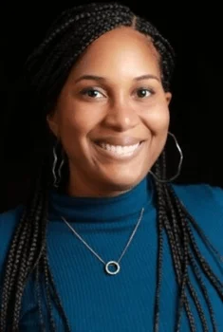
I am a Registered Psychotherapist with the College of Registered Psychotherapists of Ontario (CRPO), Canadian Certified Counsellor (C.C.C.) with the Canadian Counselling & Psychotherapy Association, a Registered Kinesiologist (Inactive) with the College of Kinesiologists of Ontario (CKO), and holds the status of Provisional Psychologist in Alberta. I hold a Master of Science in Clinical Psychology from Walden University, Specialized Honours Degree (Maj/Min) in Kinesiology and Health Science/ Psychology from York University, and Advanced Certificate in Couple and Family Therapy from the University of Guelph.
I am currently pursuing my Doctor of Psychology degree in clinical psychology with California Southern University, with the goal of licensure as a psychologist in 2023. I have hosted webinars and provided mental health commentary for Global News, Uber Canada, and Interac Canada.
I’m a former Director with the Black Health Alliance, and a former Director with the Ontario Kinesiology Association. In addition to training in the therapeutic approaches listed below, I work with pre-professional and high-performance athletes and dancers in the areas of mental performance, injury recovery, retirement, and eating disorders. I am an EMDR Certified Therapist and Certified Clinical Trauma Professional Certification (Level II – Complex Trauma), and certificate in perinatal mental health.
For the past few years, I’ve had the pleasure of helping individuals improve their mental health through goal-focused collaboration. You may be going through a time in your life right now which is leaving you feeling unhappy, or stuck in a cycle you don’t know how to break. As a Psychotherapist, I endeavor to use my skills, and the knowledge I continue to acquire to help people lead more satisfying lives. I use a client-centered and judgment-free approach and work with you to develop new skills to meet your therapeutic goals.
Each client journey is unique and so too are the factors that makes each person who they are. As the daughter of Jamaican and Trinidadian immigrants, I value the importance of culturally-integrative care in the therapeutic experience. I take an anti-oppressive and culturally-sensitive approach to my work, exploring these and the many intersections that each client holds along with the work that we do together. The richness of our different backgrounds should never be a barrier to receiving a satisfying therapy experience.
(Virtual)
Thursdays and Fridays - 11-4pm

Erin Mensch
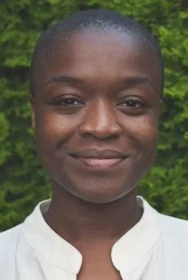
I’m a Registered Psychotherapist with the College of Registered Psychotherapists of Ontario and a yoga instructor who is passionate about improving mental health within Black, Indigenous, and People of Colour (BIPOC) communities. I received my Master of Counselling Psychology from Yorkville University, and I hold an Honours Degree from the University of Toronto in African Studies, Cultural Anthropology, and Political Science. As someone born in central Africa and raised in both southern and northern Africa before moving to Canada, my interest in healing work is rooted in a desire to apply my awareness and understanding of BIPOC experiences within compassionate and culturally-informed care.
I work with clients who feel stuck or unsure about the path they’re on in their life as well as those who may find it difficult as they navigate the challenges of day-to-day stress, painful past experiences, relationships, big life changes, or unique racialized experiences. I also work with couples who may be facing obstacles in their relationship, are thinking about ending their relationship, or who want to strengthen and deepen an already fulfilling relationship.
In my work, my priority is for you to feel respected and understood in an atmosphere of trust and nonjudgment as we explore your concerns. I also incorporate somatic practices, which are informed by my training in yoga and mindfulness. Through a holistic, anti-oppressive, LGBTI2SQ and gender-affirming approach, I tailor what I do to support your unique journey toward a greater sense of balance, wellness, healing, and continued growth.
Creating meaningful change can be empowering. My hope is that as we work together, you can see and feel the impact of positive and meaningful change in your mental health.
Virtual:
Sundays (10 am - 5 pm EST), Tuesdays (10 am - 5 pm EST), and Wednesdays (12 pm - 7 pm EST)
In-person sessions at Mondays (12 pm - 7 pm EST)

Helen Yoseph
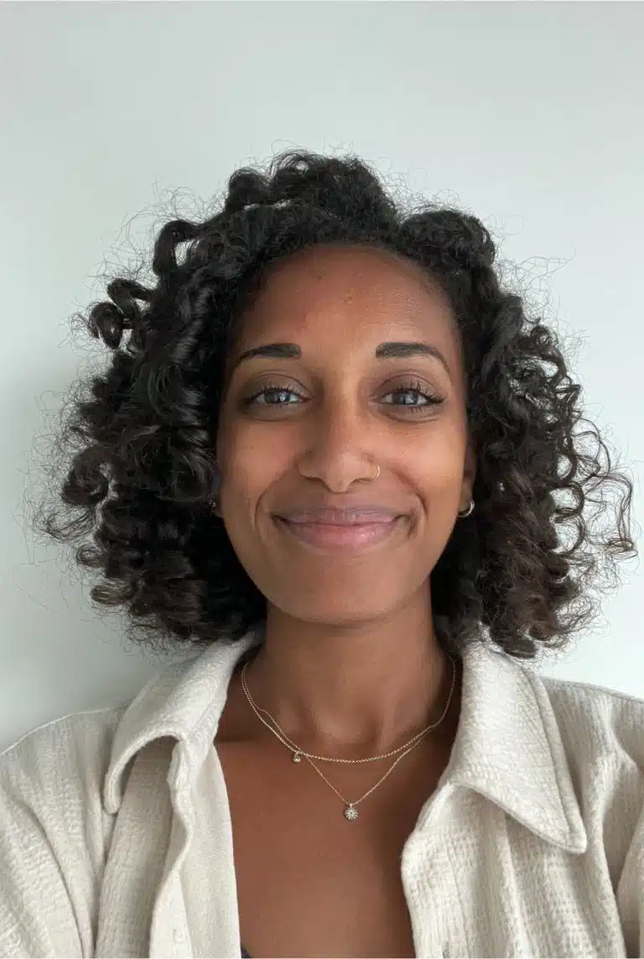
I am a Registered Psychotherapist with the College of Registered Psychotherapists of Ontario (CRPO). I received my Master of Arts in Counselling Psychology from Yorkville University and a Specialized Honours Degree in Biology and Psychology from Queen’s University. I am an avid reader and film enthusiast, and overall appreciator of all stories found everywhere.
If there are aspects of your story that you are dissatisfied with or are interested in learning how to process events and unpack experiences to name a few, then therapy might be a worthwhile avenue to explore. I am dedicated to providing accessible and affordable therapy, and committed to both working with you and walking alongside you as you learn and develop the necessary skills to lead a more fulfilling life.
My goal as a psychotherapist is to be an active support and help empower you to address your present concerns. I am passionate about working with individuals of various identities including those from multicultural populations, immigrants, and refugees, as well as individuals belonging to the Black, Indigenous, and People of Colour (BIPOC) communities.
Being vulnerable and opening up is challenging yet necessary for therapeutic change. I hope that in using a culturally-informed and client-centred therapeutic approach we can foster an environment of collaboration and trust, and together build a space where multiple stories can exist.
(Virtual)
Wednesdays and Thursdays - 9-6pm
In-person - Thursdays 12-5pm
Donna Mitchell
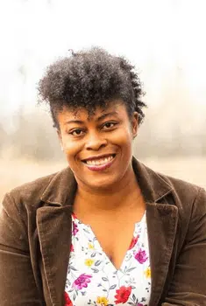
I completed my Master of Arts in Counselling Psychology at Yorkville University and am a Registered Psychotherapist (Qualifying) with the College of Registered Psychotherapists of Ontario, and Canadian Certified Counsellor with the Canadian Counselling & Psychotherapy Association.
I am Jamaican-born, and a proud mother of a wonderful son. I love spending my time with my son in the park, being in nature, hiking, visiting waterfalls, and riding bikes. My motto is, “there is something positive to take out of every struggle we experience in life.”
I embrace and encourage change in my clients. I strongly believe that every individual possesses the strength they need to foster the change required for healing.
I presently have over eight years of experience working with children, youth, families, and caregivers who are experiencing developmental disabilities such as autism, ADHD, FASD, and others. I also have experience working with individuals and families experiencing mental health issues such as depression, anxiety, stress, burnout, relationship conflicts and grief.
Through my work with individuals, I adapt a strength based approach where I believe that everyone has the innate ability to foster change. I also believe that each person is different; Therefore, I incorporate different evidence-based modalities such as Cognitive Behaviour Therapy, Narrative Therapy and Solutions Focused Therapy in my practice. My years of experience with children and families have fostered a “holistic” approach to helping others.
My work with individuals is based on compassion, respect, self-determination, acceptance and most importantly, a strong therapeutic bond.
Virtual
Monday to Thursday 10am - 3pm and 5pm - 8pm

Rhea Bridge
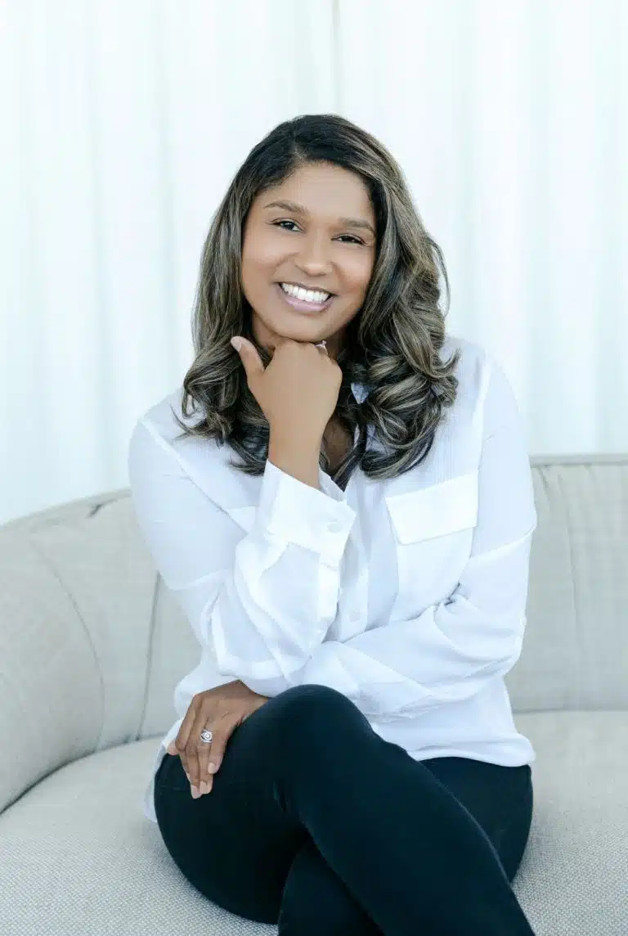
I am currently recognized by the College of Registered Psychotherapists of Ontario (CRPO) as a Registered Psychotherapist (Qualifying). As part of my ongoing psychotherapy training, I receive regular supervision from Renee Raymond at ReNu Counselling & Psychotherapy. I have completed my Masters (M.A.) in Counselling Psychology at Yorkville University, and my undergraduate degree in Psychology from York University.
I work from a client-centred and strength-based framework, where I practise an eclectic approach to therapy using modalities such as Acceptance and Commitment Therapy, Cognitive Behaviour Therapy, Narrative Therapy, and Solution-Focussed Therapy while incorporating Mindfulness, with the overarching goal of collaborating with individuals to become the best versions of themselves. I work with individuals navigating major life changes, experiencing perinatal challenges, stress, anxiety, depression, trauma, grief, relationship problems, low self-esteem, and communication difficulties
I come from a Caribbean background and was born and raised in Canada. I enjoy spending time with my family and dogs, taking walks and trips to the park. I have a life-long interest in human abilities and behaviour, which has evolved to include working with neurodiverse individuals and their families. Along my journey, I had the opportunity to volunteer with the Certified Listeners Society where I provided emotional support to individuals while encouraging self-awareness and enhancing self-discovery. This experience has brought me to the field of Counselling and Psychotherapy, where I want to continue learning, growing, and making a difference.
I believe individuals can make changes throughout their healing journey but sometimes require assistance to navigate life’s challenges. I work from a place of non-judgement and empowerment while using an anti-oppressive and trauma-informed lens. I will consider and celebrate the diverse cultures and spectrum of sexualities individuals identify with, focusing on being an ally to Black, Indigenous, People of Colour (BIPOC), immigrants, and refugees.
I aim to create a space where you feel safe, supported, and welcomed. Throughout your time with me, I hope we can build and maintain a positive therapeutic relationship together, where I can support you building positive habits, making healthier choices and live a life filled with balance and growth.
Mon to Wed from 10am-5pm
Thurs 10am- 4pm

Paul Mensah
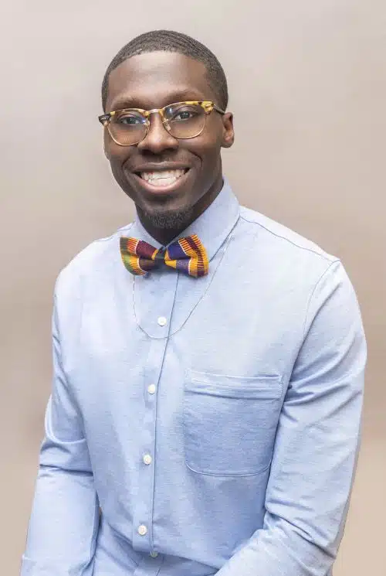
At different points in our lives, we may be faced with trials and tribulations that can be difficult, leave us uneasy, unhappy, anxious, depressed, or unsatisfied. As a developing psychotherapist, I aim to use my growing knowledge to aid those in the community combat these trying times. So, congratulations on taking the first step towards change. I work with individuals, families, teens (12+), and athletes dealing with trauma, reduction of stress, anxiety and accomplishing various life goals. I help clients reach a state of happiness, balance, and better health through a healthy therapeutic relationship and an integrative approach.
By blending therapeutic approaches, dependant on the client’s needs, I can help clients reach their desired goals. I work with diverse groups which has expanded my perspectives on varying experiences helping me better understand and support both current and future clients. I support clients in making positive changes in their attitudes and behaviors.
I work in a collaborative manner by listening to the needs, goals, and stories of my clients with the goal to leave impactful and positive changes in their mental health. All inquiries will be responded to within 24 hours, so please reach out for a free 15-minute consultation to start our therapeutic journey!
Virtual
Monday: noon - 9 pm
Tuesday: noon - 9 pm
Wednesday: 9 am - 5 pm - Thursday: 9 am - 6 pm
Shayoncé Davidson
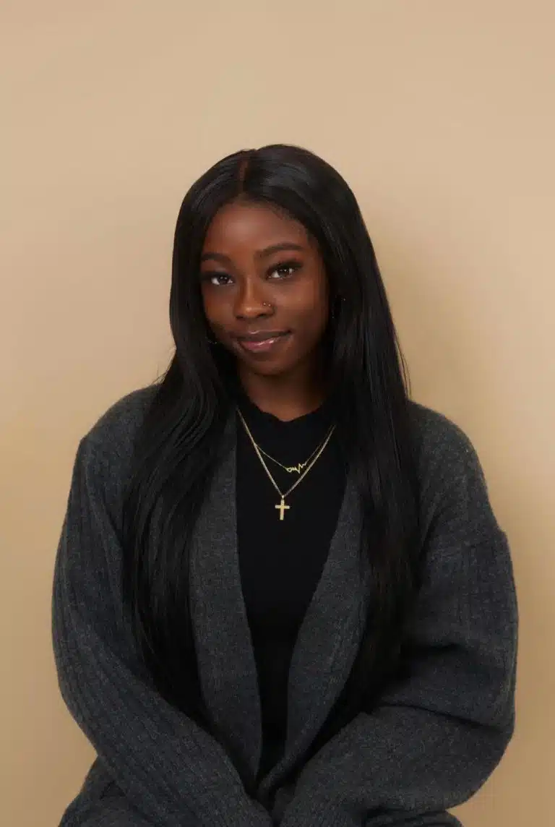
Navigating life’s challenges alone can be overwhelming, but you don’t have to. Step into a therapeutic journey where understanding meets diversity and growth is nurtured with empathy. I offer a compassionate and collaborative space to explore the complexities of your experiences. I deeply respect your expertise in your own life. I focus on understanding your unique interpretations, what holds significance for you, and how you aim to overcome challenges. I believe in the potential for transformation and growth at every stage, fostering a space where vulnerability is not just accepted but celebrated, change is nurtured, and connections are valued.
As a Caribbean/Canadian second-generation woman, my multicultural background forms the bedrock of my therapeutic approach, intertwining multicultural insights with person-centred approaches to provide a comprehensive and inclusive space for healing. As someone who has experienced different cultures and grew up in a multicultural city, I understand the importance of cultural sensitivity in therapy. I invite you to bring your authentic self into our sessions, knowing that your unique experiences and cultural heritage play a vital role in shaping your story.
My journey as a Crisis Responder has honed my skills in navigating sensitive moments and offering support during challenging times. This experience has instilled profound empathy and resilience, qualities I bring into our therapeutic space.
Beyond traditional therapy, my love for fitness and understanding mind-body connections add depth to our sessions. Whether incorporating mindful movement or exploring how physical fitness impacts mental well-being, I believe in the power of holistic approaches to healing.
Whether you’re struggling with mental health relationships or seeking personal growth, I’m here to support you. Together, we’ll craft a personalized treatment plan that aligns with your needs, drawing from evidence-based approaches. As a firm believer in the significance of mental health, I see it as the cornerstone of overall wellness. You’re not just a client but a unique individual with a story worth exploring. Let’s embark on a journey where your story is embraced, your cultural identity is honoured, and your path toward mental wellness is illuminated.

(Virtual)
Tuesdays, Thursdays, Fridays (variable times)

